Experiment 1:

Cifar 10, one hidden layer of size 20

X : Number of elements in an Activation class
Y : Number of Activation classes with this much elements.

Epoch 0 : 10 % accuracy
Unique Train Activation : 30110, Unique Test activations : 7581, Intersection : 2805
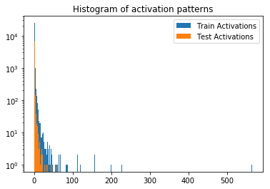

Epoch 1 : 43 % accuracy
Unique Train Activation : 20618, Unique Test activations : 6831, Intersection : 4343
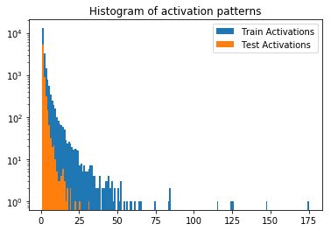

Epoch 10: 46% accuracy
Unique Train Activation : 32747, Unique Test activations : 8675, Intersection : 3886
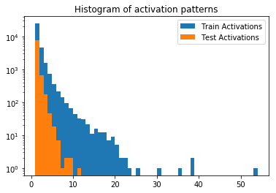

Comments :
- 20000 unique classes with an hidden layer size of 20, it’s a lot !
- Half of test activations are totally new
- Number of unique classes goes low quickly then gets back up (30k e0, 20ke1, 30ke10).

Cifar 10, one hidden layer of size 120 :

Epoch 0 : 10 % accuracy
Unique Train Activation : 50000, Unique Test activations : 10000, Intersection : 0

Epoch 10 : 52 % accuracy
Unique Train Activation : 49999, Unique Test activations : 10000, Intersection : 0

Comments :
- Intersection varies from 0 to 1 …
- 2 ** 120 = 10 ** 36 : This neural network starts to become complicated and there are some many possibilities for activation classes the network takes full advantage of this. In order to study more complicated networks clustering with a distance is necessary.
- Maybe the 0-1 threshold is too unforgiving and there are a lot of activations with very low values which could account for 0 ?

